
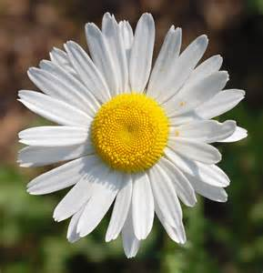
GFWC Vernon Township Woman’s Club
PO Box 175
Vernon, NJ 07462

www.vtwc.org
info@vtwc.org

Find us on Facebook
Our Meetings
Where: Vernon Senior Center in the Vernon Municipal Building, 21 Church Street, Vernon, NJ.
When: 6:30 p.m. on the fourth Thursday of each month from September through June (with some exceptions due to holidays).
What: Each meeting features an informative, educational or just plain fun program or speaker, followed by the business session where we discuss our ongoing projects and plan future activities.
Why: To simply make a difference. Attend one of our meetings as our guest and get a first-hand look at how we improve the world, one project at a time.

Why Be a Volunteer?

Every club member has her own unique reasons for volunteering, and her own explanation of the personal rewards she reaps by doing so. We could write a book with all of their thoughts, but a few famous people have summed it up nicely for us.

“I always wondered why somebody didn’t do something about that. Then I realized I was somebody.”
~ Lily Tomlin

“I am only one, but still I am one.
I cannot do everything,
but I can do something;
and because I cannot do everything,
I will not refuse to do something.”
~ Helen Keller

“It is one of the beautiful compensations of life, that no man can sincerely help another without helping himself.”
~ Ralph Waldo Emerson
Serving our community and beyond since 1972
Member of:
General Federation of Women’s Clubs
NJ State Federation of Women’s Clubs
GFWC Vernon Township Woman’s Club

About Our Club
The Vernon Township Woman’s Club (VTWC) is an all-volunteer, non-profit organization established in 1972.
Women of all ages from many towns – who share a vision of service and a commitment to helping others – come together to make a positive impact on our local community and around the world, one project at a time.
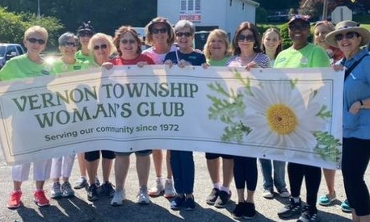
Our energy and resources are directed toward charitable, philanthropic, and educational activities that help brighten the lives of others. We focus on children, families, education, civic engagement, international programs, the environment, and public affairs.
We are driven by our motto, quoted centuries ago by the Greek dramatist Menander:

“To live is not to live
for one’s self alone;
let us help one another.”

We Make a Difference
The VTWC impacts the lives of students, families in need, US soldiers and veterans, social service agencies, nursing home residents, and many other segments of the population through a wide range of ongoing programs such as:

- Christmas gifts and Easter baskets for children living in domestic abuse and homeless shelters
- Cell phones, Christmas stockings and wool skull caps for soldiers
- Sponsor a Vernon student to attend Girls’ Career Institute at Douglass College-Rutgers
- Scholarships for high school students
- “Most Improved” awards for middle schoolers
- Birthday gifts for nursing home residents
- Monetary awards for Eagle Scouts and Girl Scouts Gold Award recipients
- Support summer enrichment programs for children of migrant farm workers
- Lap blankets for hospital patients
- Chest pillows for breast cancer patients
- Personal care items for homeless men
- Food pantry donations
- Homemade cookies for domestic abuse victims and nursing home residents
- Letters from Santa

Join Us!



Help us make a difference

in our community!

Name
___________________________________________

Address
___________________________________________

City
___________________________________________

State Zip
___________________________________________

Home Phone
___________________________________________

Cell Phone
___________________________________________

Email
___________________________________________

Month & Day of Birth
___________________________________________

Spouse’s Name (optional)

Annual dues are $40
Please complete this application
and return it to:
GFWC Vernon Township Woman’s Club
PO Box 175, Vernon, NJ 07462

