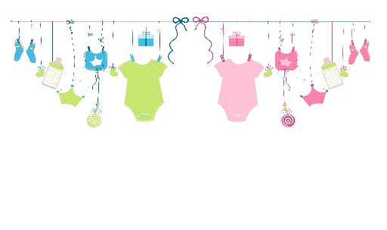
Ideas for Birth Haven Baby Shower Donations

Babies
- Assorted packs and cases of diapers in sizes newborn, 1, 2 and 3
- Baby wipes
- Baby powder
- Baby blankets
- Onesies
- Bibs
- Stuffies (for 0-3 months)
- Outfits (0-12 months)
- Crochet or knitted items, blankets, hats booties

Mommies
- Bath and body items
- Panties and sports bras
- Nail color
- Hair accessories
- Soft robes or cardigans (one size fits most)
- Lip moisturizer
- Journals
- Gift cards

